Hello vendor!

There are 5 projects in this document for you to quote:

1. LED Strips + Power Connections
2. 3-output Y Cable
3. M10 Signal extensions
4. M10 Signal pigtails
5. MC4 Load pigtails

We eagerly await your lead time and cost estimate for DDP incoterms, shipped air freight.

Or contact me by email:

Jeff Vyduna

vyduna@gmail.com

Thank you!

# Project 1: LED Strips and Power Connections

We would like you to manufacture custom length strips with a basic wiring harness used for power injection.

|  |  |
| --- | --- |
| Total parts (LED strip + wire + connectors) | 639 |
| Unique part numbers | 213 |
| Unique LED strip lengths across the 213 parts numbers | 62 |
| Shortest strip (60/m) | .75 m (45 LEDs) |
| Longest strip (60/m) | 4 m (240 LEDs) |
| Total SK9822a LEDs | 82,470 |
| Waterproofing | IP67 silicone tube |

## List of parts to make for Project 1

This Google Sheet contains the [list of part numbers and corresponding strip lengths](https://docs.google.com/spreadsheets/d/1D8YOJPwXsvH9rhAUYCfv1nNLrANHbZlE-w_0LIYnJHw/edit#gid=0) to make.

[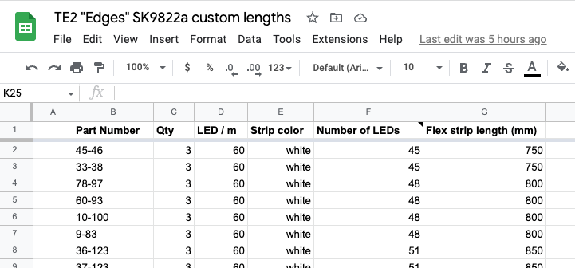](https://docs.google.com/spreadsheets/d/1D8YOJPwXsvH9rhAUYCfv1nNLrANHbZlE-w_0LIYnJHw/edit#gid=0)

If you cannot access Google Sheets, I have also attached the sheet as an .XLSX spreadsheet.

## Diagrams for Project 1

All diagrams can also be downloaded in full resolution from [this Google Drive folder](https://drive.google.com/drive/folders/1-D_6iE-ZmextEcplrH_688s4951_1ha9?usp=sharing).

If you cannot access Google Drive, I have also attached all these diagrams as a .zip file called “Edge RFQ Diagrams.zip”.

## Project 1 Written Description

Each part is manufactured with:

1. A white flexible strip of 60/m SK9822a LEDs.
   1. All connections are soldered to the underside of the strip, and head the opposite direction from normal strips (wires are soldered to head back towards the center of the strip). They curve back to meet the 10 AWG “power rails”.
2. A rectangular silicone tube cut to about 10mm shorter than the strip (5mm each side), and 2 clear silicone caps to be glued on with clear silicone sealant.
3. 3-pin data-in and data-out M10 mini waterproof
   1. Data in: 3-wire GND-DAT-CLK, 160mm long, going to an M10 waterproof male 3-pin connector. The manufacturer may use their suggested pin assignment.
   2. Data out: 3-wire GND-DAT-CLK, 420mm long, going to an M10 waterproof female 3-socket connector. The manufacturer may use their suggested pin assignment, but it must be consistent (chainable with male connector).
   3. Data-in and Data-out may either use a jacketed 3-conductor cable or use a 3-conductor zip cord, 20-24 AWG (use largest allowed by molded connector). If the wires are visible such as with a zip cord, the desired colors are:
      1. GND: Black (preferred); Blue is acceptable
      2. Data: Green
      3. Clock: Yellow
4. “Power injection taps”: An 18 AWG Red (+) and Black (GND) bonded pair (“zip cord”) at beginning and end of strip, cut to 420mm long. One side is stripped for soldering to the strip, and one side is stripped to be crimped *with* the 10AWG wire.
5. “Power injection rails”: A 10 AWG Red (+) and Black (GND) bonded pair (“zip cord”) which is 760mm longer than the part’s LED strip, crimped into the MC4 terminals *with* the 18AWG power tap wires.
   1. Two wires are crimped into each MC4 terminal (the same color in 18 AWG and 10 AWG)
   2. The MC4 terminals and housings must be the ones made for 6 mm^2 wires (10 AWG)
   3. The terminals **must NOT** be inserted into their MC4 housings. We will do this ourselves as part of our assembly process.
   4. On an MC4, the male pin terminal is always used with a female housing, and a female socket terminal is always used with a male housing. Note the genders described here are for the terminal gender, not the housing.
   5. On the Data-in side:
      1. Red (+) is crimped into the male pin terminal.
      2. Black (GND) is crimped into the female socket terminal.
   6. On the Data-out side, it is reversed:
      1. Black (GND) is crimped into the male pin terminal.
      2. Red (+) is crimped into the female socket terminal.
6. Two mini zip ties. A zip tie surrounds all cables on each end (3 signal wires, 2 power injection taps, and 2 power injection rails). Both sides are tightened and clipped about 80mm from the strip.
7. The part number shall be labeled around the 10 AWG bonded pair, under the strip, near the data-in side.
   1. If you can do water-resistant white shrink-wrap labels with printed part numbers, this is most preferred
   2. Other printed water-resistant labels (such as flag style adhesive labels) are good
   3. If not, permanent marker written on plastic adhesive labels is ok
   4. There are qty:3 of each part number, so three parts will always have the same part number.
   5. Some parts are identical (same number of LEDs), but have different part numbers.

# Project 2: 1-to-3-way waterproof Y-adapters

Using the same M10 waterproof molded connectors as for project 1, we want you to manufacture a 3-way splitter.

Qty: 240

Overall length: 260 mm

Data-in: 1x Male 3-pin M10 waterproof connector

Data-out: 3x Female 3-pin M10 waterproof connector

20-24 AWG conductors (largest allowed)

It is a normal Y-cable: In other words, 4 total GND are soldered or spliced to each other. 4 total DAT and 4 total CLK are also soldered or spliced.

Junction: Over molded

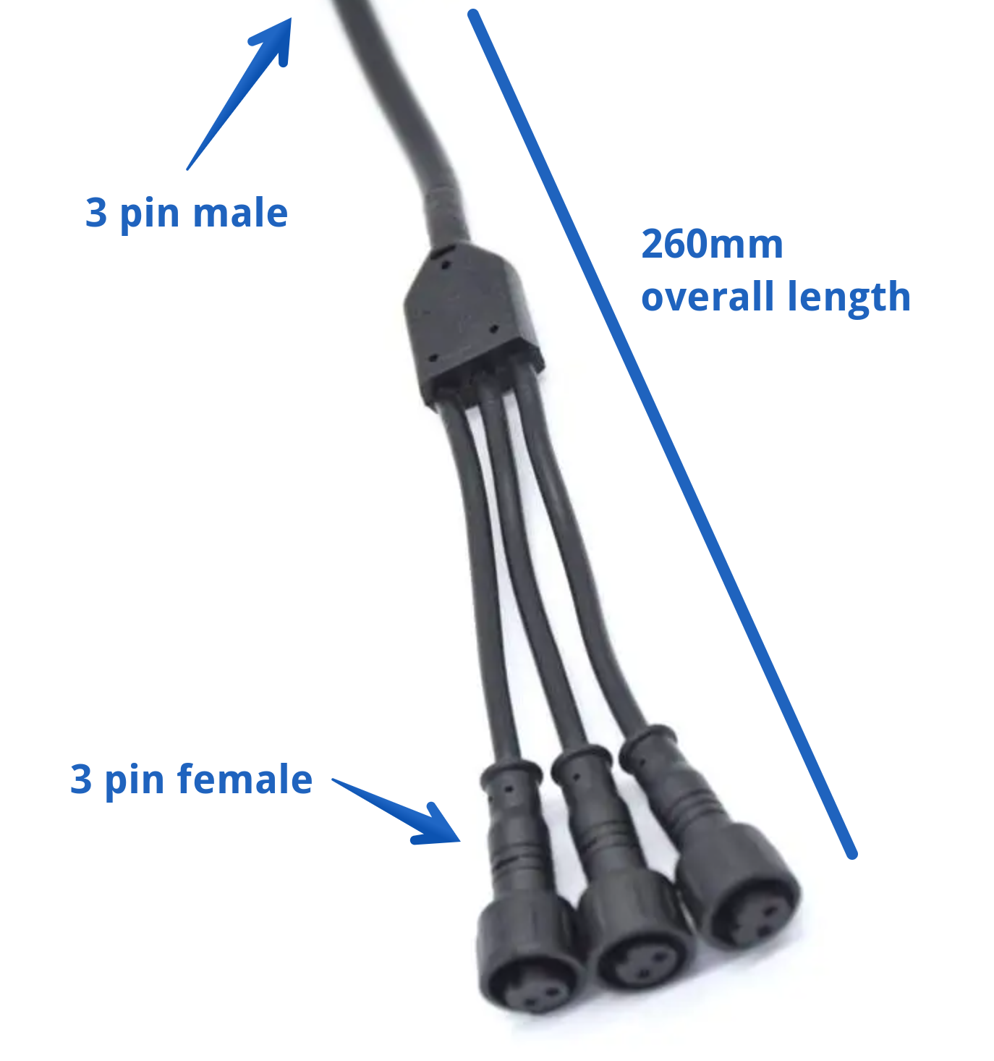

# Project 3: Signal extensions

Qty: 150

Length: 2000 mm

Male-Female M10 3-pin waterproof extension cables

# Project 4: Signal pigtails

Qty: 240

Length: 500 mm

Side 1: Female M10 3-pin waterproof pigtails

* Use same pin assignment and colors as all other projects
  + Best: GND = Black. OK: GND = Blue
  + Data = Green
  + Clock = Yellow

Side 2:

* Outer jacket removed 60mm
* Each of the three conductors is stripped 6mm and tinned

# Project 5: MC4 Load pigtails

Qty: 200

6 mm^2 (10 AWG) Red-Black bonded pair

Length: 300 mm

Side 1: MC4s for 6mm^2

* Red is crimped into the male pin terminal and inserted into the female housing
* Black is crimped into the female socket terminal and inserted into the male housing.

Side 2: Stripped 13mm and tinned